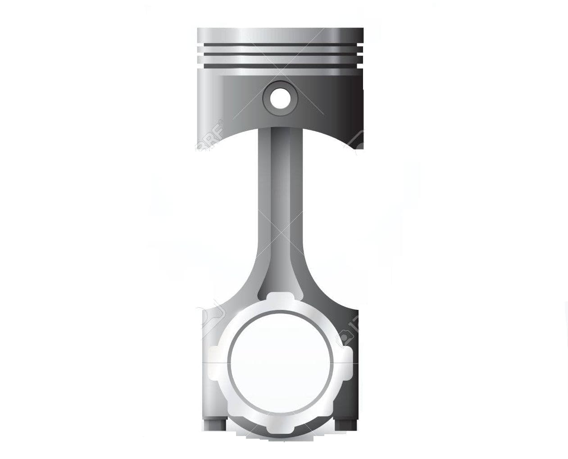

1. **PISTON - A disk or short cylinder fitting closely within a tube in which it moves up and down against a liquid or gas, used in an internal combustion engine to derive motion, or in a pump to impart motion.**

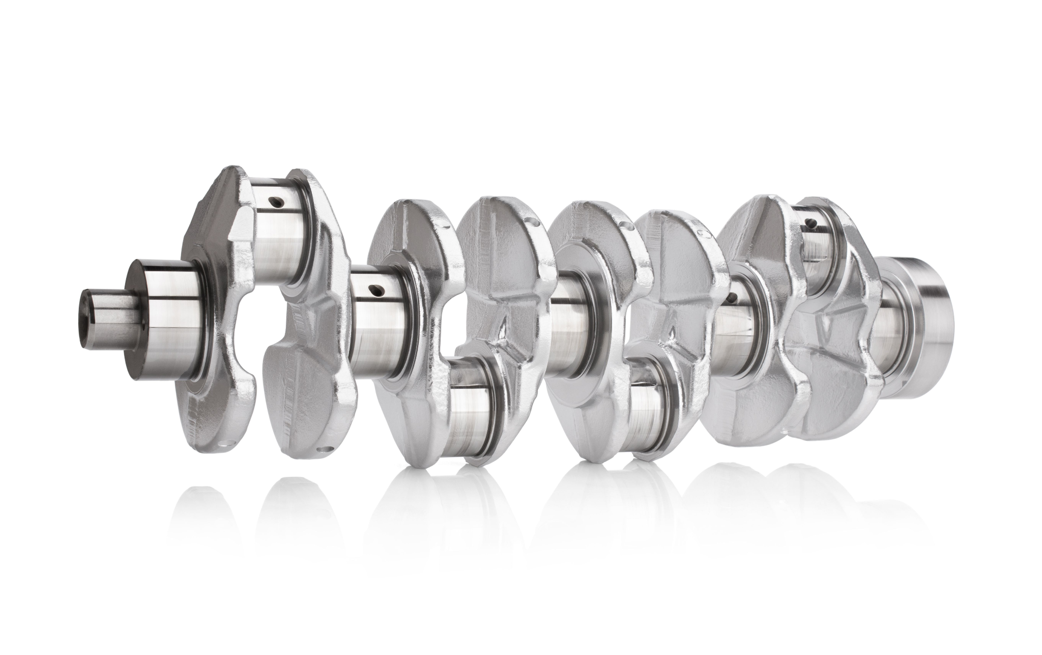

1. **CRANKSHAFT - A shaft driven by or driving a crank: a shaft consisting of a series of cranks and crankpins to which the connecting rods of an engine are attached.**

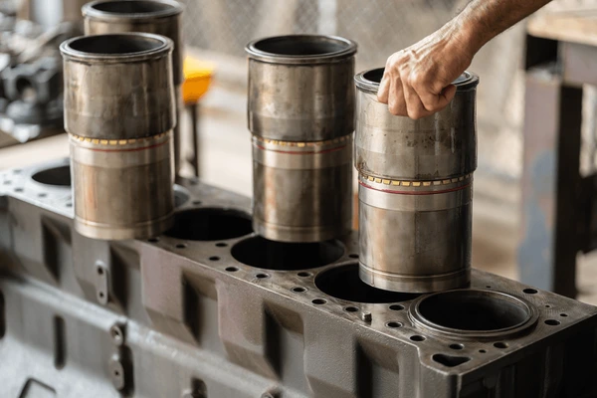

1. **CYLINDER LINER - A cylinder liner, also known as a cylinder sleeve, is a cylindrical component inserted into an engine block to provide a durable, smooth, and wear-resistant surface for the reciprocating motion of the piston within an internal combustion engine, ensuring efficient sealing and lubrication**

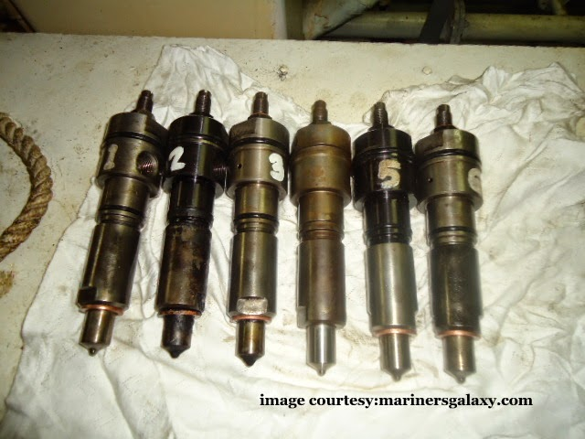

1. **FUEL INJECTOR - is a device that delivers a precise amount of fuel into an engine's combustion chamber, typically at the right time, for efficient combustion. It acts as a spray nozzle, atomizing and injecting fuel into the intake manifold, combustion chamber, or throttle body.**

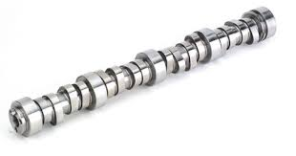

1. **CAMSHAFT - is a rotating shaft in an internal combustion engine that uses cams to control the opening and closing of valves, ensuring the proper intake of air and fuel and the expulsion of exhaust gases. These cams, which are attached to the shaft, are shaped in a way that, as the shaft rotates, they push on valve lifters, forcing the valves open.**

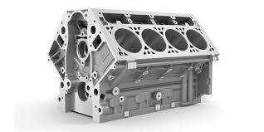

1. **ENGINE BLOCK - the engine block, also known as cylinder block, is a critical component that forms the foundation for the engine's key parts, including the cylinders, pistons, and crankshaft. It's essentially the sturdy housing that holds and supports these vital components, facilitating the engine's operation.**

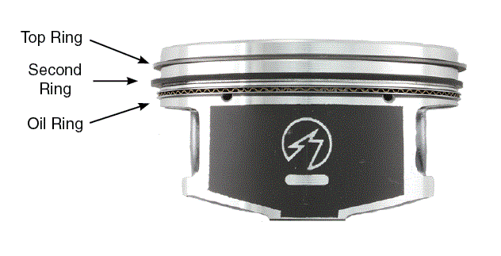

1. **PISTON RING - are expandable split rings fitted to the outside of a piston in an internal combustion engine. Their primary functions are to seal the combustion chamber, prevent oil from leaking into the combustion chamber, and help conduct heat from the piston to the cylinder wall.**

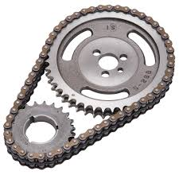

1. **TIMING CHAIN - is a metal chain that synchronizes the rotation of the crankshaft and camshaft(s) in an engine, ensuring the valves open and close at correct times. It's a crucial part of the engine that helps ensure proper combustion and engine performance**

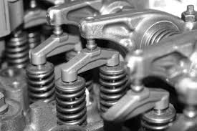

1. **ROCKER ARM - is a valvetrain component that typically transfers the motion of a pushrod in an overhead valve internal combustion engine to the corresponding intake/exhaust valve.**